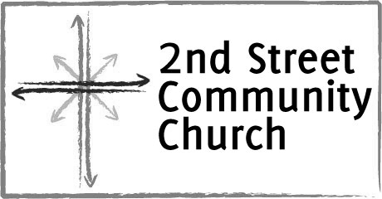
Volunteer Screening Form/Statement

The purpose of this form is to help our church provide a safe and secure environment for children, youth, and adults with disabilities who participate in our programs and use our facilities.

This application is to be completed by all applicants for any regular position involving the supervision or custody of minors and/or adults with disabilities. This is not an employment application form.

Date___________________

Name
First Middle Last

Present (home) address

City _______________ State ____Zip _________ E-mail

Phone (home) (_____)_________________ Phone (cell) (_____)_________________

Marital status ______ Spouse's name ___________________

List three former addresses with dates:

- What is the minimum length of commitment you can make? (Six months preferred)
- How long have you attended 2nd Street Community Church? ______________
- List (names and addresses) of other churches you have attended regularly during the past five years, including dates:

- List all previous church work involving children, youth, and adults with disabilities. Show name and address of church and type of work with dates.

- List all previous non-church work involving children, youth, and adults with disabilities. Show name and address of organization and type of work performed with dates.

- Please list three personal references, including your current pastor. References may not include relatives. If possible, your references should be people who are familiar with your experiences working with children, youth, or adults with disabilities. Preferably, they should be people who have known you at least five years, if not longer.
Please contact these people and inform them that they will be contacting them for a reference.

Name
Address
City ___________________ State _______ Zip
Email
Phone (______)

Name
Address
City ___________________ State _______ Zip
Email
Phone (______)

Name
Address
City ___________________ State _______ Zip
Email
Phone (______)

Updated 9.30.12

Volunteer Statement of Agreement

2nd Street Community Church

The information contained in this application is correct to the best of my knowledge. I authorize any references or churches listed in this application to give you any information (including opinions) that they may have regarding my character and fitness for working with children/youth/adults with disabilities. In consideration of the receipt and evaluation of this application by 2nd Street, I hereby release any individual, church, youth organization, charity, employer, reference, or any other person or organization, including record custodians, both collectively and individually, from any and all liability for damages of compliance or any attempts to comply, with this authorization. I waive any right that I may have to inspect any information provided about me by any person or organization identified by me in this application. I understand that a criminal background check may be conducted every year as long as I am working with children, youth, and people with disabilities.

I have read the PROTECTION AND ABUSE PROTECTION POLICY of 2nd Street Community Church.

Should my application be accepted, I agree to be bound by the policies and procedures of 2nd Street, and to refrain from unscriptural conduct, as defined by 2nd Street, in the performance of my services on behalf of the church.

I further state that I HAVE CAREFULLY READ THE FOREGOING RELEASE, AND KNOW THE CONTENTS THEREOF AND I SIGN THIS RELEASE AS MY OWN FREE ACT. This is a legally binding agreement which I have read and understood.

Applicant's Signature ______________________________ Date ___/ ___/ ___

Note: If you are applying to be a volunteer worker you will be interviewed by the director of the appropriate ministry. If you prefer to be interviewed by the senior pastor, please check here [__].

Note: All pages of this form are CONFIDENTIAL and will be filed in a safe, secure place.

Updated 9.17.12

